Lecture 5:
Bitcoin and Blockchain
Bitcoin is one of the first protocols to utilize blockchain technology. Bitcoin could facilitate peer-to-peer transactions within a decentralized network using cryptography. This gave rise to censorship-resistant finance and presented Bitcoin as a superior digital store of value(digital gold). There is a fixed amount of Bitcoin, similar to the scarcity of gold.

Ethereum and Smart Contracts
A few years after Bitcoin's creation Ethereum was built upon the blockchain infrastructure, but with additional capabilities. With Ethereum, you can create decentralized transactions, organizations, and agreements without a centralized intermediary. This was achieved through the addition of smart contracts.
What are smart contracts?
Smart contracts are a set of instructions executed in a decentralized way without the need for a centralized or third party intermediary.
They run on blockchains and automatically execute when predetermined conditions are met, unmodifiable, without the need for intermediaries and everyone can see it.

Smart Contract functionality is the primary difference between blockchains like Ethereum and Bitcoin. Technically Bitcoin does have smart contracts but they're intentionally turing incomplete.

The Oracle Problem
However, smart contracts face a significant limitation – they cannot interact with or access data from the real world. This is known as the Oracle Problem.
Blockchains are deterministic systems, so everything happens within their ecosystem.
Oracles serve this purpose.To maintain decentralization, it's necessary to use a decentralized Oracle network rather than relying on a single source. This combination of on-chain logic with off-chain data leads to hybrid smart contracts.

Chainlink
Chainlink is a popular decentralized Oracle network that enables smart contracts to access external data and computation. Chainlink is also blockchain agnostic - so it's going to work with any chain out there.

Layer 2 Scaling Solutions
As blockchains grow, they face scaling issues. Layer 2, or L2, solutions have been developed to address this. L2 solutions involve other blockchains hooking into the main blockchain, essentially allowing it to scale. There are two primary types of L2 solutions:
- Optimistic Rollups: eg. Optimism, Arbitrum
- Zero-Knowledge Rollups: eg. ZKsync, Polygon ZK EVM

Terminology
- Blockchain: In web3, a blockchain is a digital ledger that records transactions across many computers in a secure and decentralized manner
- Oracle: Oracles in web3 are intermediaries that provide smart contracts with external data. They act as bridges between blockchains and the outside world
- Layer 2: Layer 2 solutions in web3 are technologies built on top of a blockchain (Layer 1) to improve its scalability and efficiency. These solutions handle transactions off the main chain, reducing congestion and fees, and then settle the final state on the main chain
- Dapp (Decentralized Application): A Dapp is an application that runs on a decentralized network, typically a blockchain. It is powered by smart contracts and operates without a central authority. Dapps can serve various purposes, from finance to gaming
- Smart Contract: In web3, a smart contract is a self-executing contract with the terms of the agreement directly written into code.
- Hybrid Smart Contract: Hybrid smart contracts combine on-chain code (running on a blockchain) with off-chain data and computations provided by oracles
- Ethereum/EVM (Ethereum Virtual Machine): Ethereum is a blockchain platform known for its smart contract functionality. The Ethereum Virtual Machine (EVM) is its computation engine that executes smart contracts. Ethereum allows developers to build decentralized applications and is the basis for many web3 projects.
Web3
Web3 is a term used to describe the new paradigm of the internet powered by blockchain and smart contracts.
Web1: The permissionless open sources web with static content
Web2: The permissioned web, with dynamic content centralized management
Web3: The permissionless web with dynamic content.
- Decentralized censorship resistant networks run your agreements and code.
- User owned ecosystems where one owns a portion of the protocol they interact with - instead of solely being the product

Lecture 6:
The Essence of Blockchain and Smart Contracts
Almost every interaction or transaction in our lives involves some form of agreement or contract. For instance, purchasing a chair involves a contract to buy lumber, assemble it, and sell the finished product.
Almost everything we do in modern life relates to an agreement or contract in some way.
To make it more relatable, think of contracts and agreements as promises. Traditional contracts require trust between parties, and this doesn’t always work in favour of honesty and fairness.
In the 80s and 90s, McDonald’s Monopoly game promised customers a chance to win money through game cards obtained with purchases. However, it turned out that the game was rigged by insiders who manipulated the system for their gain. Essentially, McDonald’s failed to keep its promise.
This example demonstrates that relying on trust within agreements can lead to fraudulent activities and broken promises.

The Problem with Traditional Agreements
- Consumer Trust
With smart contracts, we can eliminate the need for trust. A smart contract is an agreement or a set of instructions that are deployed on a decentralized blockchain
- Banking and Trust
Traditional banks have sometimes failed to keep the promise of safeguarding people's money, as seen during the Great Depression. Blockchain and smart contracts can ensure transparency and execute automated solvency checks, preventing the bank from becoming insolvent
- Financial Markets Access
Centralized bodies, like traditional exchanges, have the power to restrict access to financial markets. This was evident when Robinhood restricted trading on certain assets in 2021. With decentralized exchanges like Uniswap, there is no central authority that can alter or limit market access
- Under the Hood
Smart contracts are relatively new, but have already started transforming various markets. They do this by representing 'promises' as code on the blockchain. This code is executed by a decentralized collective, such that no single entity can alter the agreement in any way
Blockchain results in trust-minimized agreements or what can be simply termed as unbreakable promises.
- Beyond Trust Minimization
It is important to note that blockchain, smart contracts, and cryptocurrencies are not just about trust-minimized agreements. They offer security benefits, uptime advantages, execution speed, and much more.
- Caution: Not All Are Equal
However, beware of platforms that claim to be decentralized but are not in practice. An example from 2022 is the SBF's FTX platform. It presented itself as a Web3 platform, but was essentially a traditional Web2 company using cryptocurrency without the benefits of smart contracts.

Lecture 9:
Features of Smart Contracts
Smart contracts come with various features that distinguish them from traditional agreements.
Decentralization
smart contracts do not rely on any centralized intermediary. Instead, they run on a blockchain which is maintained by thousands of individuals known as node operators.
It is important to note that this transparency does not necessarily compromise privacy. Blockchain is pseudo-anonymous, meaning that your transactions are not directly tied to your real-world identity.
Transparency and Flexibility
Transparency is inherent to blockchain networks. Since all node operators can see everything happening on-chain, there is no room for unfair or hidden deals.
Speed and Efficiency
Smart contracts and blockchain transactions are incredibly fast and efficient compared to traditional banking systems. For example, bank transfers, especially international ones, can take up to several weeks, whereas blockchain transactions happen almost instantly.
Security and Immutability
Once a smart contract is deployed, it cannot be altered or tampered with. This immutability ensures that the terms of the contract are set in stone. The decentralized nature of blockchain makes hacking nearly impossible since an attacker would have to take control of more than half the nodes.
The data on a blockchain is resilient. In a traditional system, if your computer and backups fail, you lose all your data. In contrast, in a blockchain, your data is replicated across thousands of nodes. Even if several nodes were to go down, your data would remain secure as long as there is at least one copy of the blockchain.

Elimination of Counterparty Risk
Smart contracts eliminate the need for trust in transactions. Once a smart contract is deployed, its terms cannot be changed. This means that parties cannot alter the agreement based on greed or any other factors.
Applications of Smart Contracts
Decentralized Finance (DeFi)
DeFi allows users to engage with financial markets without relying on centralized intermediaries
Decentralized Autonomous Organizations (DAOs)
DAOs are governed entirely by smart contracts and operate in a decentralized manner. This structure offers benefits such as transparent governance, efficient engagement, and clear rules.

Non-Fungible Tokens (NFTs)
NFTs can be thought of as digital art or unique assets. NFTs have created new avenues for artists and creators to monetize their work.

Lecture 12:
Testnets
A testnet (test network) is a separate blockchain network used for:
Testing, development, and experimentation without risking real assets or affecting the main blockchain (mainnet).
  - We'll be using a virtual testnet tool called "Tenderly." This is our preferred method for interacting with a testnet.
Testnet Exploration
A testnet explorer is a blockchain explorer designed specifically for a testnet chain such as Etherscan or Blockscout
Sending a Testnet Transaction
To send a transaction on a Testnet, we need to use a faucet. A faucet allows us to get free Testnet tokens.

Blockchain explorer
The primary function of a blockchain explorer tool is to provide a user-friendly interface for viewing and searching blockchain data in real-time.
- Token Tracking (for smart contract platforms)
- Network Status Monitoring
- Viewing Transactions
- Viewing Blocks
- Address Lookup
LECTURE 13:
Understanding Transaction Details
You can view any blockchain transaction’s full details on a blockchain explorer. Important details include:
- Transaction hash: A unique identifier for the transaction.
- Status: Whether the transaction was successful.
- From: The address that sent the transaction.
- To: The address that received the transaction.
- Value: The amount of ETH sent (in this case, 0.1 Test ETH).

LECTURE 14:
Transaction Fee and Gas Price: What are they?
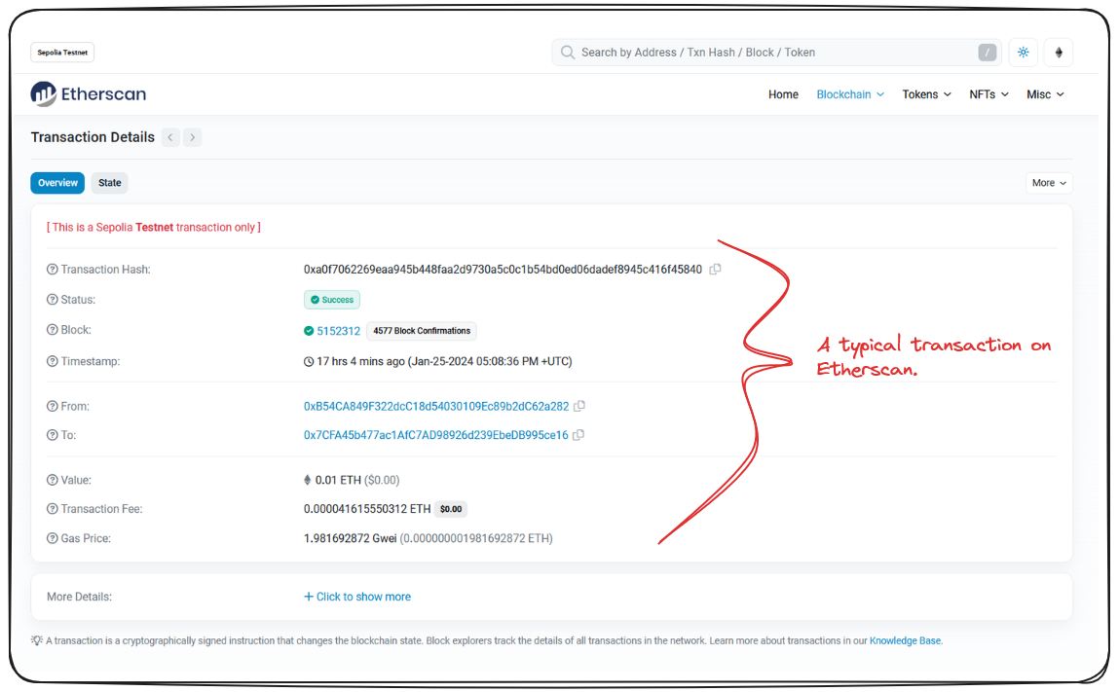
Transaction fee
the amount rewarded to the block producer for processing the transaction. It is paid in Ether or GWei.
Gas price
It is the cost per unit of gas specified for the transaction, defined in either Ether or GWei, The higher the gas price, the greater the chance of the transaction being included in a block.
Gas
gas refers to the computational effort required to execute the transaction, gas price is the cost per unit of that effort.

The Role of Nodes in Blockchain
Blockchains are run by a group of different nodes, sometimes referred to as miners or validators, depending on the network. These miners get incentivized for running the blockchain by earning a fraction of the native blockchain currency for processing transactions. For instance, Ethereum miners get paid in Ether, while those in Polygon get rewarded in MATIC, the native token of Polygon. This remuneration encourages people to continue running these nodes.
Understanding Gas in Transactions
In the context of transactions, gas signifies a unit of computational complexity.
The higher a transaction's complexity, the more gas it requires. For instance, common transactions like sending Ether are less complex and require relatively small amounts of gas. However, more sophisticated transactions like minting an NFT, deploying a smart contract, or depositing funds into a DeFi protocol, demand more gas due to their complexity.
The total transaction fee can be calculated by multiplying the gas used with the gas price in Ether (not GWei). Therefore, Transaction fee = gasPrice * gasUsed.

Lecture 16:

Understanding Hash Functions
At its simplest, a hash is a unique, fixed-length string that serves to identify any piece of data.
When you input any kind of data into a hash function, it produces a hash. In this demo, the hash algorithm we'll focus on is SHA-256.

If I add Patrick Collins to our SHA-256 algorithm, it will:
- Convert the letters to numbers
- Convert the numbers to a fixed-length “string” or “hash”

Even a tiny change in input results in a drastically different hash. This is known as the avalanche effect.

Ethereum, uses its own version of a hashing algorithm (Keccak256) that isn't exactly SHA-256 but belongs to the SHA family.
The fascinating aspect is, no matter how much data is input, the length of the generated hash string remains constant.

Function | Description
Data Integrity | Hashes ensure data has not been altered. If data changes even slightly, the hash changes completely.
Block Linking | Each block contains the hash of the previous block → creates the chain in "blockchain".
Proof of Work | Miners solve for a valid hash (with required difficulty), securing the network.
Efficient Data Verification | Hashes allow fast checking of large data (e.g. Merkle trees for transactions in a block).
Digital Fingerprint | Every transaction, block, and address has a unique hash identifier.

Understanding Blocks
The structure of a blockchain is nothing but collection of "blocks."
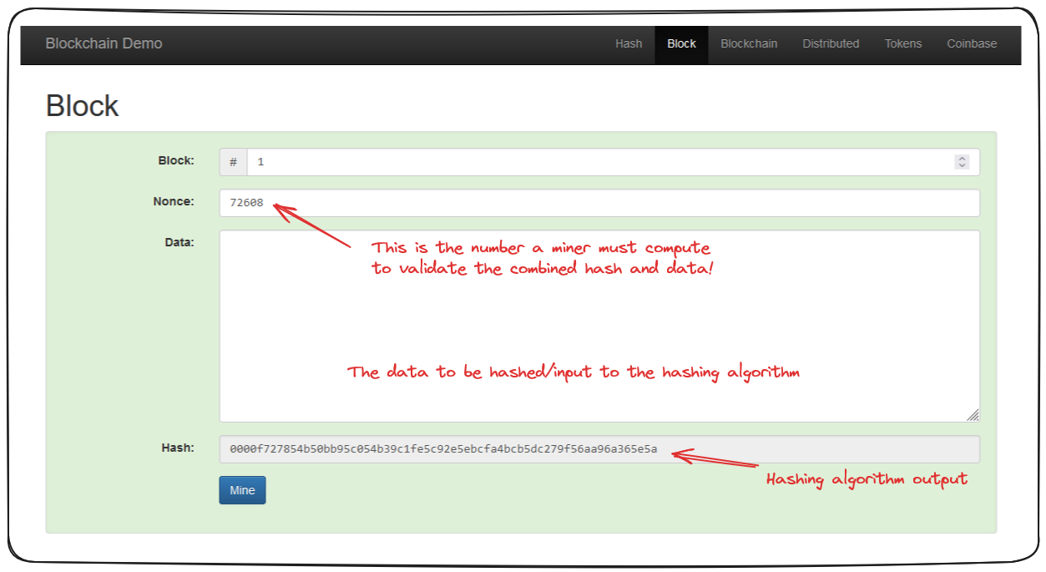
A block takes the same data input, but instead of a singular data field, A block is a small container with:
- Block Number (e.g., 1)
- Nonce (a special number to solve the puzzle)
- Data (any meaningful content, like transactions)
- Hash (output of hashing all the above)
The first three are then run through the hash algorithm, producing the hash for that block.
As a result, even a minor change in the data leads to an entirely different hash, hence, invalidating the block.
In essence, mining involves the computational trial and error process of finding an acceptable value to produce a hash which typically follows a certain pattern, such as starting with "0000" (proof of work). Means, To add a block to the blockchain, you must solve a puzzle — finding a nonce such that the hash starts with some pattern, like "0000".
Nonce:
The value found, which satisfies this criterion, is known as the 'nonce'.
The Inherent Beauty of Blockchain: Immutability
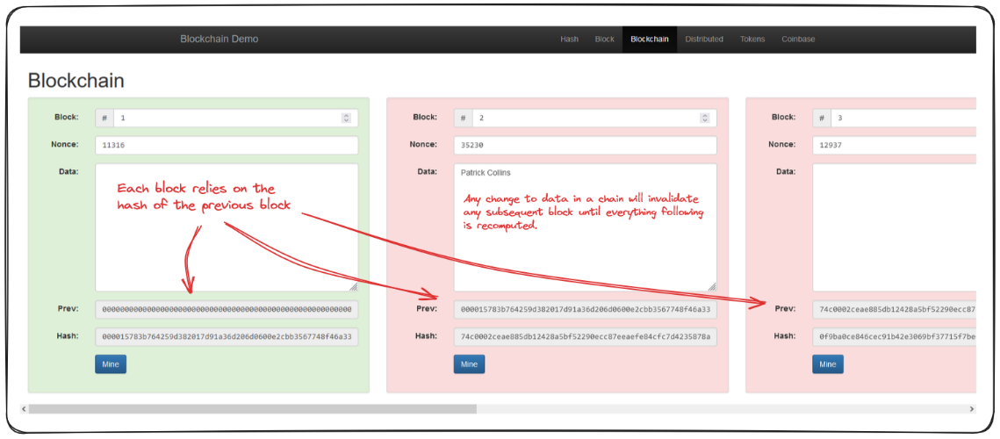
In a blockchain, which is essentially a sequence of blocks, each block is comprised of the previous elements - a block number, a nonce and data - as well as the hash of the previous block

Now, if someone changes Block 2's data to "C pays D 100 coins":
- Block 2's hash changes.
- But Block 3 still points to the old
hash of Block 2.
- So Block 3 becomes invalid.
                - Chain breaks unless you recalculate
(mine) all blocks after the change.
This makes tampering very computationally expensive and detectable.

Genesis Block: This is the first block in a blockchain. Which contains a hash which does not exist.

Decentralized Distribution
Now, if a single entity were to control the blockchain, they could conceivably change any data they want, and then re-mine, or re-validate subsequent blocks. This is bad.

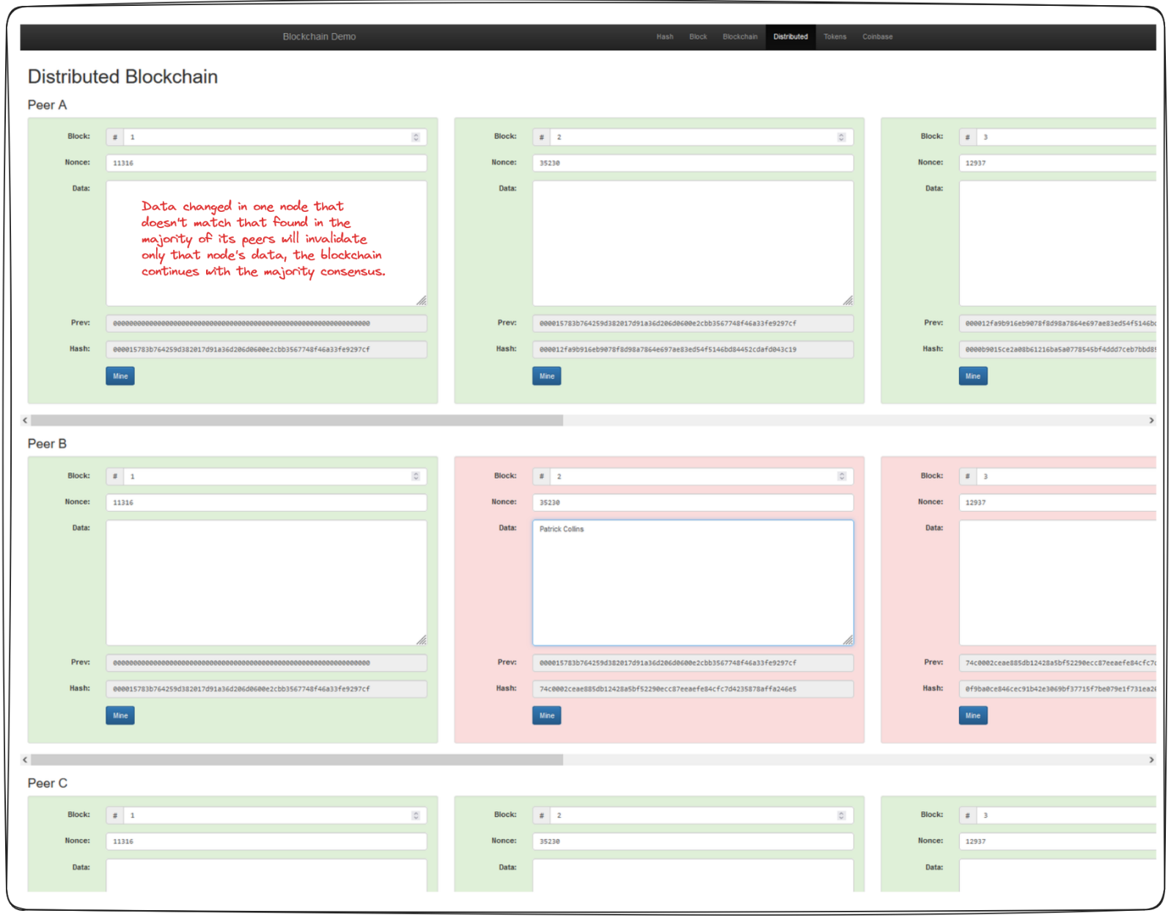
Why decentralization matters:
If one person controlled the entire blockchain, they could:
- Change a transaction.
- Recalculate all hashes (re-mine).
- Control history.
This is bad. Instead, blockchain uses a network of nodes (peers).
Each node has its own copy of the blockchain.
If someone tampers with their copy, other nodes reject it.

Interplay of Blockchain & Transactions
Until now we've been considering the data passed in a block to be a random string of text, but the reality is - this data can be anything. In the token and Coinbase sections of this demo you can see how each block is comprised of a number of transactions that all get hashed together.
Any edits to any of these transactions is going to invalidate the chain!
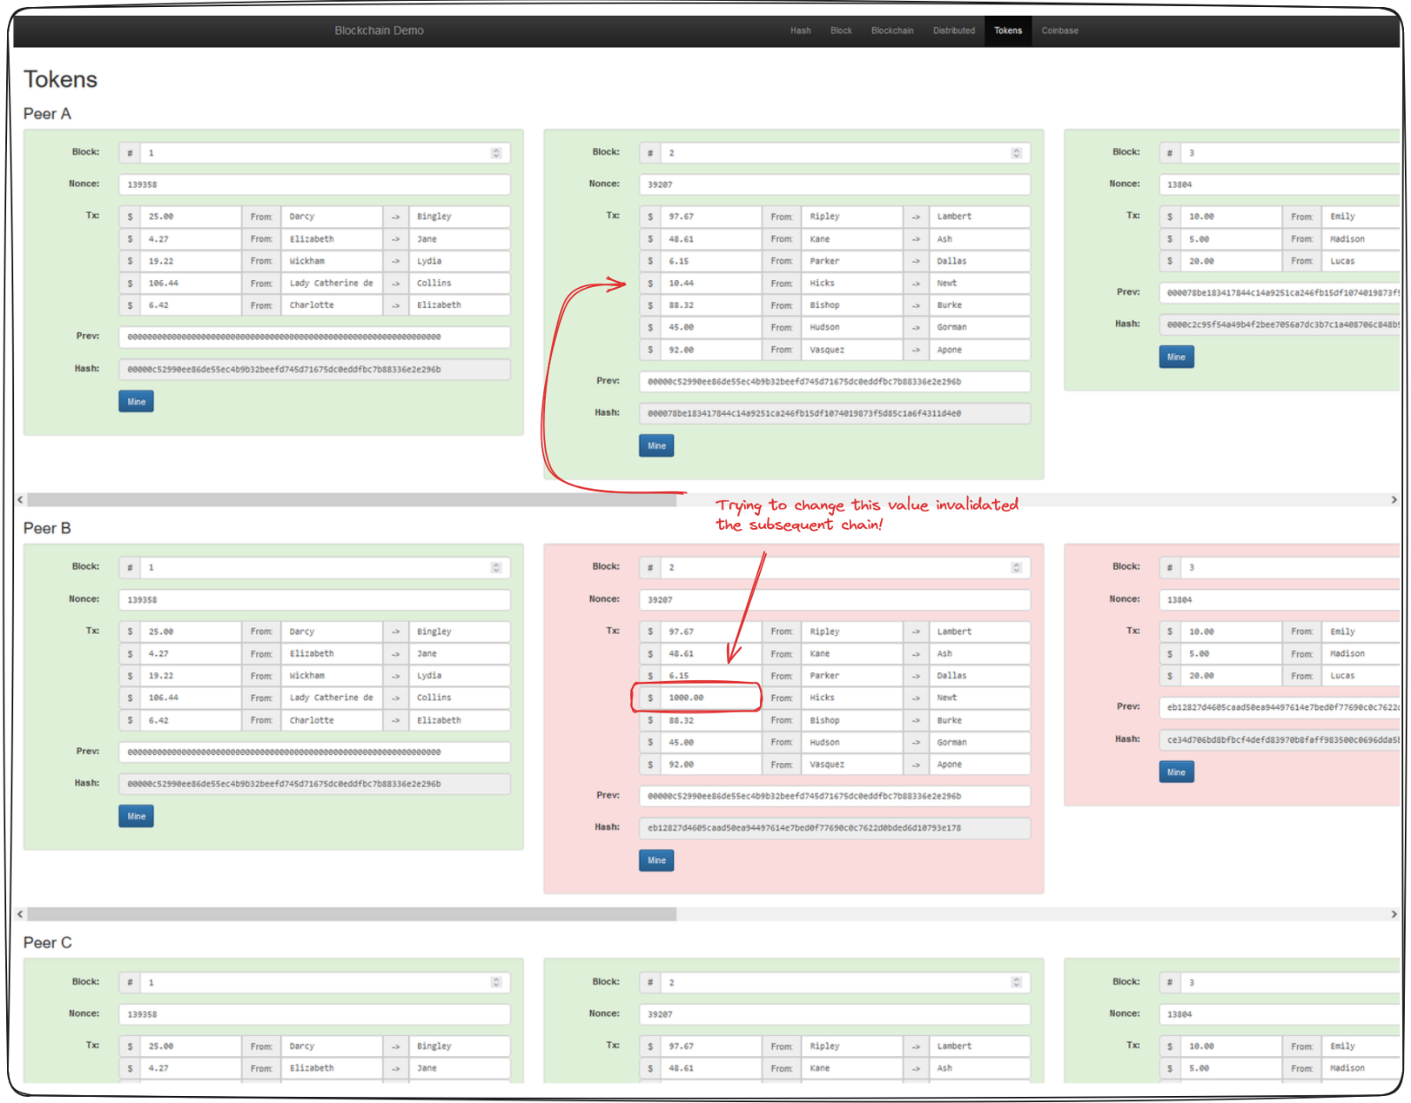
What do miners do?
Miners in Proof-of-Work (PoW) blockchains like Bitcoin or Ethereum 1.0 do the following:
- Collect Transactions
They gather unconfirmed transactions from users (e.g., "Alice sends 2 BTC to Bob").
- Create a Block
They bundle those transactions into a block.
- Mine the Block
They try different nonces to find a block hash that satisfies the network's difficulty target (like a hash starting with "000000...").
- Broadcast the Block
Once found, they send the block to the network.
- Get Verified
Other nodes verify that:
  - All transactions are valid.
  - The hash is correct and satisfies the difficulty.
- Get Rewarded 💰
If valid, the miner receives a block reward, often including:
  - A fixed number of newly created coins (e.g., 6.25 BTC for Bitcoin as of 2024).
  - Plus transaction fees from all transactions in the block.
That’s what mining feels like:
A race, requiring computation, luck, and electricity.

Lecture 17:
Public and Private Keys
A private key is a randomly generated secret key used to sign all transactions.
The private key is then passed through an algorithm (the Elliptic Curve Digital Signature Algorithm for Ethereum and Bitcoin) to create the corresponding public key. Both the private and public keys are central to the transaction process. However, while the private key must remain secret, the public key needs to be accessible to everyone.
When we send a transaction to the blockchain, we're passing a private key. This allows others to verify the transaction through the generated public key.
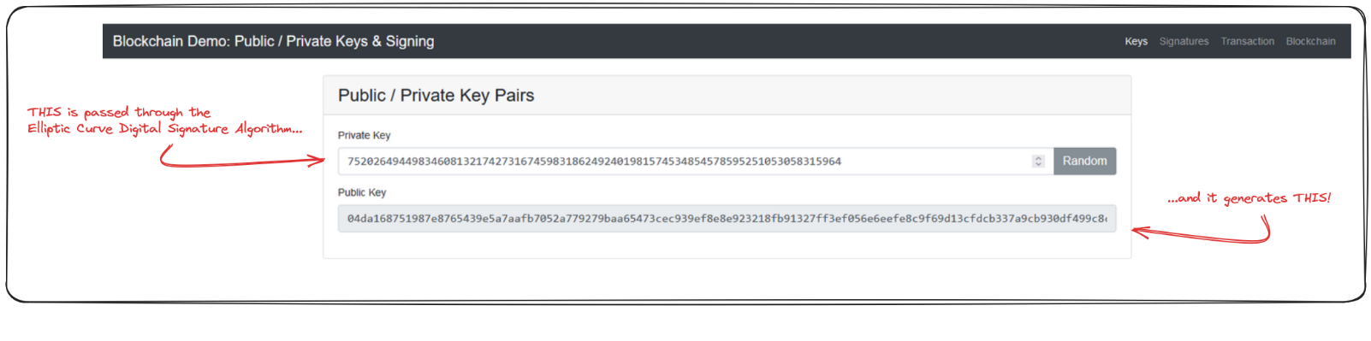
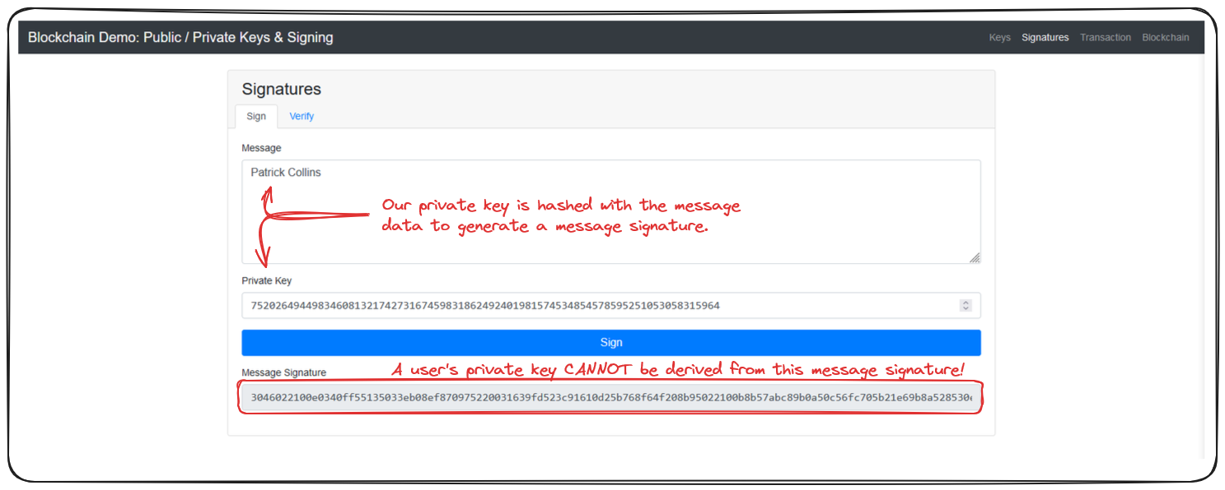

How does Transaction Signing Happen?
When we sign a transaction on the blockchain, we're digitally signing some data with our private key. The hashing algorithm used makes it impossible for something to derive your private key from a message signature.

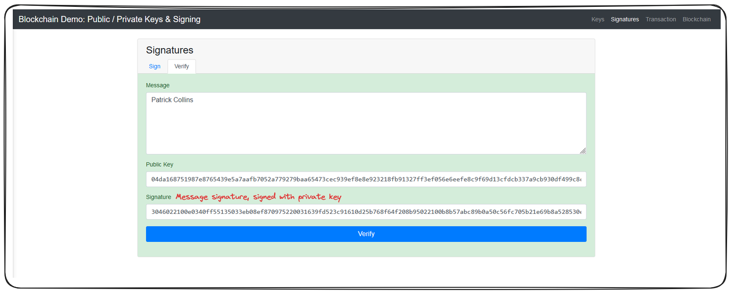
This signing method allows anyone to verify the validity of a transaction by comparing the message signature to a user's public key!
The Verifying Process (done by anyone, publicly):
- Others receive:
  - The original message.
  - The signature.
  - Your public key (or wallet address that can be used to derive the public key).
Now, using the rules of Elliptic Curve Cryptography, anyone can mathematically check:
Does Signature match Public Key for this Message?

- Private Key -> Your secret seal (only you know how to stamp it)
- Public Key -> The template others use to verify your seal
- Digital Signature -> The actual stamped seal on this specific letter

Concept | Same Every Time? | Why?
🔐 Private Key | ✅ Yes | It’s your identity — like a master password
🔓 Public Key | ✅ Yes | Derived from your private key, doesn’t change
🖊️ Digital Signature | ❌ No | It’s unique for every transaction, even if the message is the same

Importance of Hiding Private Keys
Anyone with access to your private key can perform and sign transactions, on your behalf consequently making it absolutely vital to safeguard private keys.
Note: As an interesting side note, wallet addresses, like the one MetaMask provided to you, are actually derived from your public key. A public key is passed through the Ethereum Hashing Algorithm, the last 20 bytes of the resulting hash is the address!

Does a Block contain the public key and digital signature?
✅ Yes — but indirectly, as part of the transactions inside the block.
Not at the block level, but yes at the transaction level.

What’s in Each Transaction (Inside the Block)?
Each transaction inside the block contains:

Field | Purpose
📤 Sender Address | Derived from sender’s public key
📥 Receiver Address | Recipient’s wallet address
💸 Amount | How much to send
🖊️ Digital Signature | Verifies the sender authorized the transaction
🔓 (Recoverable) Public Key | Used to verify the signature (in some blockchains it's explicitly included; in others it's recovered)

Every block has many transactions, and each transaction contains (or reveals):
- a digital signature
- and a public key (explicit or recoverable)

Lecture 18:
Note: What we're covering here is applicable to Ethereum post implementation of EIP-1559 wherein gas limits, priority fees and the discussed burn mechanism were all introduced.
Transaction Breakdown
Before we continue, there are a couple important terms to understand.
- Wei: 1,000,000,000 Wei = 1 Gwei (Gigawei)
- Gwei: 1,000,000,000 Gwei = 1 Eth
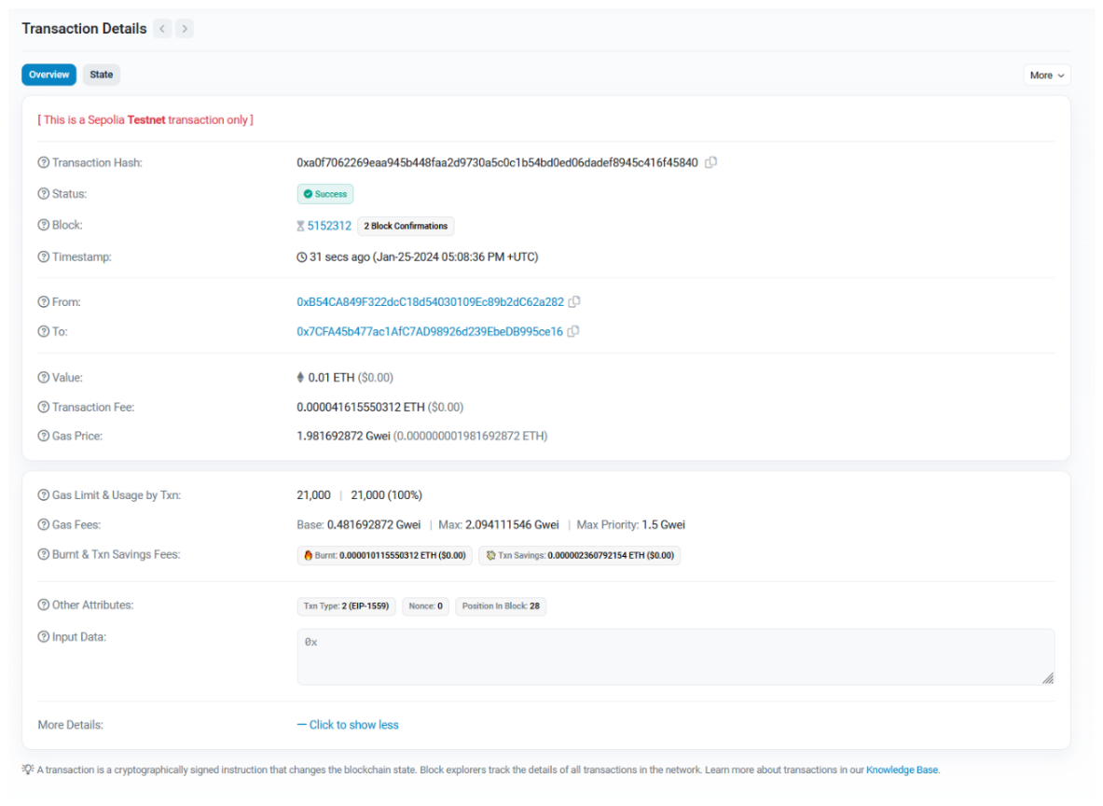

Reference the above image, the labelled sections will be detailed below
1. Transaction Fee: This is calculated as :
Total Gas Used * Gas Price
where Gas Used represents the computational units required to perform the work and Gas Price is comprised of a Base and
Priority Fee
2. Gas Limit: This is the maximum amount of gas allowed for the transaction. This can be set by the user prior to sending a transaction.
3. Base Gas Fee: The base fee of a transaction, represented in Gwei. Remember, this is cost per gas.
There are a couple important points to note regarding the Base Fee
- The fee is burnt as of EIP-1559. Burning serves to remove the value from circulation, combating inflation on the protocol. The amount burnt can be seen beneath the Base Fee in the image above.
- The fee is dynamic, under EIP-1559, if a block is more than 50% full, the Base Gas Fee is increased for the next block. Likewise, if a block is less than 50% full, the fee decreases. This serves to balance network demand and capacity.
4. Max Gas Fee: This is the maximum cost per cast the transaction has been configured to allow. This can again be configured prior to sending a transaction.
5. Max Priority Fee: Again, configurable prior to sending a transaction, this represents the maximum tip we're willing to give miners. This incentivizes the inclusion of our transaction within a block.
6. Block Confirmations: These are the number of blocks which have been mined or validated which have been confirmed to contain your transaction. The more confirmations the more sure we can be of the transaction's validity.
What Does "Confirmation" Mean?
In blockchain (especially Ethereum):
- A confirmation happens when a transaction is included in a newly mined/validated block.
- Once that block is added to the chain, your transaction has 1 confirmation.
So:
🔹 0 confirmations = Your transaction is still pending, not included in any block.
🔹 1+ confirmations = Your transaction has been successfully included in a block that is now part of the blockchain and transaction in complete.

Lecture 19:
Traditional Networks vs Blockchain
Traditionally, when you run an application be it a website or something that connects to a server you are interacting with a centralized entity. This is the opposite of what you may recall from our distributed blockchain example
Blockchains, as we saw, run on a network of independent nodes. In our previous example, each of the Peers was representative of an independent node operator.
Node:
The term node typically refers to a single instance of a decentralized system, Peer A would be a node.
This network, this combination of these nodes interacting with each other is what creates a blockchain.

What makes these networks so potent, is that anybody can join. All anyone needs is a little bit of hardware and you can participate in securing a blockchain network
In the traditional world applications are run by centralized entities and if that entity goes down or is malicious or decides that they want to shut off - they just can. They're the ones that control everything.
Blockchains, by contrast, don't have this problem. If one node or one entity that runs several nodes goes down, since there are so many other independent nodes running, it doesn't matter, the blockchain and the system will persist so long as there is at least one node always running.
Luckily for us, the most popular chains like Bitcoin and Ethereum have thousands and thousands of nodes. Malicious nodes are kicked from the network, or even punished in some cases. Majority rules when it comes to the blockchain.
This gives blockchains this incredibly potent immutability trait where nothing can be changed or corrupted so in essence we can think of a blockchain as a decentralized database. In the case of Ethereum it has an extra additional feature where it also can do computation in a decentralized manner now.

Consensus
Let's talk consensus. This includes
- Proof of Work
- Proof of Stake.
The mining feature of our previous blockchain example was an example of Proof of Work
Proof of Work and Proof of Stake fall under this umbrella of consensus.
Consensus is defined as the mechanism used to reach an agreement on the state or a single value on the blockchain especially in a decentralized system.
Very roughly, a consensus protocol in a blockchain or decentralized system can be broken down into two pieces:
- chain selection algorithm
- sybil resistance mechanism.
Mining, or Proof of Work, is a sybil resistance mechanism. This is what Bitcoin currently uses.
Proof of Work is known as a sybil resistance mechanism because it defines a way to figure out who is the block author or which node did the work to mine a block.
The term comes from a famous psychological case ("Sybil") where one person had multiple personalities — similarly, in a Sybil attack, one entity pretends to be many independent participants.

What is a Sybil attack?
A Sybil attack happens when one person (or group) creates many fake identities (nodes/accounts) to gain influence or control over a system that assumes "more participants = more trust."
Sybil resistance is a blockchain's ability to defend against users creating a large number of pseudo-anonymous identities to gain a disproportionately advantageous influence over said system.
As mentioned, there are two primary types of sybil resistance:
- Proof of Work
- Proof of Stake
We'll look a little closer at Proof of Work first.
Proof of Work
Proof of work is a system of sybil resistance used in many blockchains, in its essence a miner needs to go through a very computationally heavy process (mining) to find the block's answer. As a result, it doesn't matter how many additional nodes you're running, each node is obligated to do this work in order to receive a reward. The playing field is kept fair.
Note: Some blockchains may make their riddle or their block answer intentionally hard, or intentionally easy to adjust the block time - which is the average time it takes to mine a block. Blocktime is proportional to how difficult these algorithms are.
Proof of Work needs to be combined with a chain selection rule to create consensus.
A chain selection rule is implemented as a means to determine which blockchain is the real blockchain.
Bitcoin (and prior to the merge, Ethereum), both use something called Nakamoto Consensus. This is a combination of Proof of Work (Etherum has since switched to Proof of Stake) and the longest chain rule.
In the longest chain rule, the decentralized network decides that whichever chain has the most number of blocks will be the valid, or real blockchain.
You'll sometimes hear people use Proof of Work to describe a consensus mechanism, but it's a little bit inaccurate, it's really the combination of sybil resistance and chain selection that create consensus.
Proof of Work also serves as a means to determine who receives transaction fees as we discussed earlier. These transaction fees are paid by whomever initiates the transaction. In a Proof of Work system, every node is competing against eachother to solve the block problem first. The first node to solve the problem gets paid the transaction fees accumulated in the block they mine. In addition to this, miners are also paid a block reward, the block reward is given by the blockchain itself.
If you've previously heard of the Bitcoin Halving - this is the concept of the block reward being cut in half roughly every 4 years.
Block rewards are in the blockchains native currency - Bitcoin = BTC, Ethereum = ETH. This effectively increases the amount of that cryptocurrency in circulation.
Blockchain Attacks
There are two major types of attacks that exist in the blockchain space.
- Sybil Attack - When a user creates a number of pseudo-anonymous accounts to try to influence a network.
- 51% attack - Occurs when a single entity possesses both the longest chain and majority network control. This would allow the entity to fork the chain and bring the network onto the entities record of events, effectively allowing them to validate anything.
Blockchains are very democratic. The bigger a blockchain is, the more decentralized, the more secure it becomes.
Proof of Work does come with drawbacks. For example, Proof of Work consumes a LOT of electricity. When you have thousands of nodes all working as hard as they can to solve a block problem the energy consumption is HUGE and as such, so is the potential environmental impact.
With the above in mind, many protocols are choosing the shift to a different consensus mechanism that is more environmentally friendly. The most popular of which is...
Proof of Stake
In contrast to trying to solve a block problem, Proof of Stake nodes put up some collateral that they are going to behave honestly aka they stake. If a node is found to be misbehaving, it's stake is slashed. This serves as a very effective sybil resistance mechanism because for each account, the validator needs to put up more stake and misbehaving risks losing all that collateral.
In a Proof of Stake system, miners are known as validators. They aren't actually mining blocks, they're validating other nodes.
Unlike in Proof of Work, where each node is racing to solve the block problem first, in Proof of Stake, validators are pseudo-randomly chosen to propose the next block and other nodes will validate it.
Proof of Stake of course comes with its own Pros and Cons.
Pros:
- great sybil resistance mechanism
- great for the environment, much less energy
Cons:
- seen as less decentralized due to upfront staking costs
This raises the question of how decentralized is decentralized enough? and I think I need to leave that to the community to decide.
Layer 1 and Layer 2
I want to briefly touch on the concepts of Layer 1 and Layer 2 networks here as well.
- Layer 1 solutions: This refers to base layer blockchain implementations like Bitcoin or Ethereum.
- Layer 2 solutions: These are applications added on top of a layer one, like Chainlink or Arbitrum.
Layer 2s like Arbitrum and Optimism are special in that they're trying to solve the problem of scalability. These protocols leverage something called rollups. We won't go too deep, but the idea is that the protocols bundle their transactions to be processed by a Layer 1.

Lecture 20:
Blockchain layers
A Layer 1 (L1) blockchain is the base layer of the blockchain ecosystem, where nodes help the chain to reach consensus. It operates without any additional plugins and is often referred to as the settlement layer. Examples of L1 chains include Bitcoin, BNB Chain, Solana, and Avalanche. Applications directly deployed on Ethereum, like Uniswap, are not considered L2s but rather dApps on L1.
A Layer 2 is any application built on outside an L1 blockchain that hooks back into it. There are different types of Layer 2, for example Chainlink, a decentralized Oracle networks and event indexing networks like The Graph, which enable applications to access on-chain data. But the most popular type of L2 is the rollup, or L2 chain.

Rollups
The idea is simple:
→ Instead of sending every transaction directly to L1, many transactions are bundled (rolled up) into one.
→ The bundle is then submitted to L1 as a single transaction.
This saves gas fees because the cost of one L1 transaction is shared across all users in the rollup batch.
Rollups help solve the blockchain trilemma:

Property | Ethereum (L1) | Rollups (L2)
Decentralization | ✅ | ✅
Security | ✅ | ✅ (inherits from L1)
Scalability | ❌ | ✅ (more transactions per second)

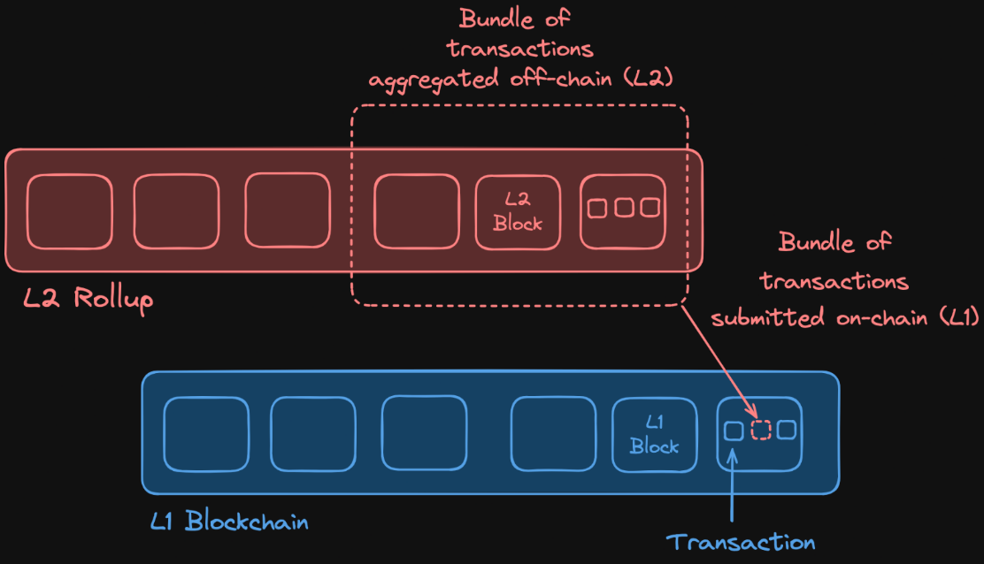

In the case of Ethereum, scalability is sacrificed as it can only process approximately 15 transactions per second. Rollups, on the other hand, aim to enhance scalability without compromising security or decentralization.

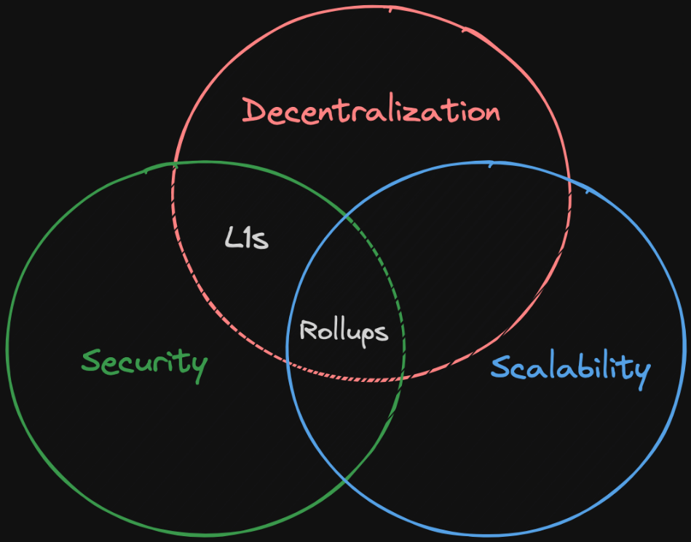
How Rollups Work
When a user submits a transaction to a rollup, an operator (a node or entity responsible for processing transactions) picks it up, bundles it with other transactions, compresses them, and submits the batch back to the L1 blockchain. This process allows for efficient handling of transactions as gas costs associated with the transaction, are split among all the users that submitted the transactions in the batch.
There are two types of rollups,
1. Optimistic rollups
2. Zero-Knowledge rollups.
The main difference between the two lies in how each rollup verifies the validity of the transactions.
Optimistic Rollups
They assume that off-chain transactions are valid by default. Operators propose the valid state of the rollup chain, and during a challenge period, other operators can challenge potentially fraudulent transactions by computing a fraud proof.
This fraud proof process involves the operator engaging in a call and response interaction with another operator to identify and isolate a specific computational step. This specific step is then executed on the Layer 1 blockchain: if the result differs from the original state, it indicates that the transaction was fraudulent. When the fraud proof succeeds, the rollup will re-execute the entire batch of transactions correctly, and the operator responsible for including the incorrect transaction will be penalized, usually by losing staked tokens (slashing).
Zero-Knowledge (ZK) Rollups
ZK rollups use validity proofs, known as zk proofs, to verify transaction batches. In this process, the prover (operator) generates a zk proof to show that their inputs (the transactions) satisfy this equation. A verifier (an L1 contract) then checks this proof to ensure that the output matches the expected result. The solution that the prover uses to demostrate that their input satisfies the mathematical equation in the zk proof is commonly referred as the witness.

Lecture 21:
Sequencer
In blockchain and cryptocurrency networks, the role of a sequencer is crucial for ordering and bundling transactions. Sequencers are operators that are responsible for organizing how transactions are processed. In many roll-up solutions, sequencers are centralized, controlled by a single entity.
Centralization risks
Censorship and Manipulation
Centralized sequencers have the power to selectively block or delay specific transactions. For example, users might experience blocked withdrawal transactions, preventing them from accessing their funds. Additionally, centralized control enables the manipulation of transaction order for personal gain.
Operational Downtime
If a centralized sequencer experiences downtime, all transaction processing can halt. This means no transactions, including withdrawals, can be processed until the sequencer is back online.

To mitigate the issues associated with centralized sequencers, projects like zkSync are working towards decentralizing their sequencer operations, distributing control among multiple entities or nodes.

Lecture 23:
A Layer 2 (L2) chain's maturity is evaluated based on specific properties and categorized into stages. The L2B team provides an opinionated assessment to encourage a progression towards a greater decentralization.
Rollup Stages
Stage | Trust level | Decentralization | Control by whom?
Stage 0 | High trust needed | Very centralized | Team/operator
Stage 1 | Less trust needed | Partially decentralized | Smart contracts + team
Stage 2 | Trustless | Fully decentralized | Smart contracts only

ZKSync Risk Analysis
In the L2Beat summary it's possible to see the actual stage of each rollup:
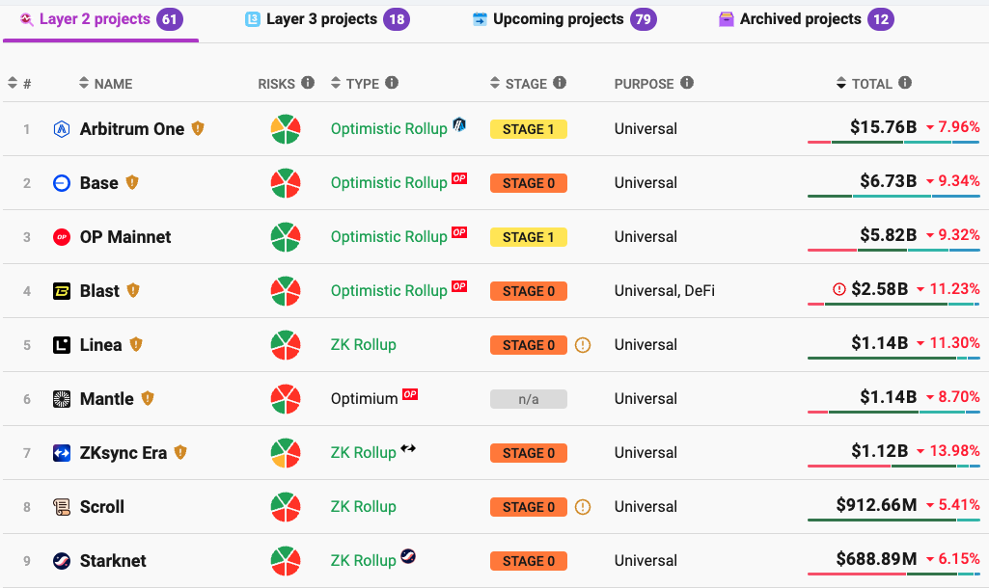

Now what is Layer 3 (L3)?
Layer 3 sits on top of Layer 2.
Its purpose is to bring more specialization and customization.
Layer | Main Focus | Example
L1 | Security + settlement | Ethereum
L2 | Scalability | Arbitrum, zkSync
L3 | Application-specific scaling / customization | Some new projects

L3s offer:
1. More customization:
- You can build specialized chains for gaming, DeFi, social apps, enterprise, etc.
2. Even cheaper fees:
- L2 fees are already cheaper than L1.
- L3 can reduce fees even further by batching inside L2 before settling on L1.
3. Privacy features:
- Some L3s might focus on privacy use cases that L2 doesn’t provide directly.
4. App-specific logic:q
- You can modify consensus rules, governance, tokenomics at the app level.

Currently, Zksync Era is operating as a Stage 0 rollup. In the dedicated page on L2, we can find a risk analysis:
- Data Availability: refers to the ability to reconstruct the L2 state from L1 data, ensuring that anyone can verify and rebuild the L2 state if necessary.
- State Validation: involves verifying the legitimacy of a set of bundled transactions. For ZK Sync, this is done using zero-knowledge proofs through an algorithm known as PLONK (Permutations over Lagrange-bases for Oecumenical Noninteractive arguments of Knowledge).
- Sequencer Failure: describes the ability to process transactions even if the sequencer is down. In ZK Sync, transactions can still be submitted to L1, though not necessarily enforced immediately.
🗒️ NOTE
The sequencer is the operator responsible for ordering user transactions and often batching them before committing them to Layer 1.
- Proposer Failure: describes the ability to process transactions even if the proposer is down. In this case, ZK Sync will halt all withdrawals and transactions executions.
- Exit Window: In the current ZK Sync stage, there is no window for exit during unwanted upgrades.

Lecture 24:
Bridging Funds
Our first transaction involves receiving funds. There are two ways to receive funds on zkSync:
- Using a Faucet: This method is used to get fakecurrency for testnets
- Bridging: Our recommended method, that involves transferring funds from one chain to another. There are two types of bridging mechanisms:
  - Locking and Unlocking: Tokens are locked on the source chain and unlocked on the destination chain.
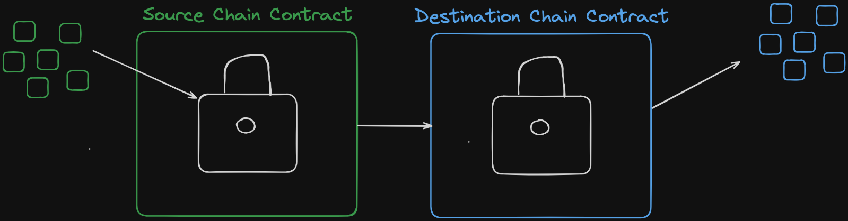
  - Minting and Burning: Tokens are burned on the source chain and minted on the destination chain. The bridge protocol must control the token supply to manage this process. An example is CCTV by the Circle team, where USDC is burned and minted to facilitate bridging.
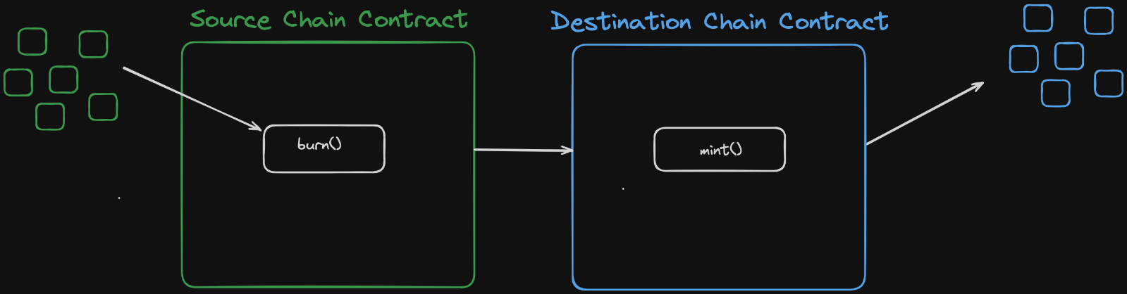
- Get Sepolia ETH: Use the recommended faucet to obtain Sepolia ETH. With 0.05 Sepolia ETH, you're ready to transfer to zkSync Sepolia.
  - Note: If you encounter a message requiring 0.001 ETH on the mainnet, wait 10-20 minutes before trying again.
- Use the zkSync Bridge: Visit the zkSync bridge and ensure you are on the testnet. Connect MetaMask to the bridge and confirm a transaction (e.g., 0.025 Sepolia ETH).
- Verify the Transaction: Check the transaction on the zkSync Sepolia block explorer by pasting your wallet address into the search bar to see the transaction details and status.
  - Transaction Status: Once processed, you can view the transaction information, including its status.
  - Finality: T his term refers to the time from sending the transaction to when it is considered settled. On Ethereum, this takes about 13 minutes, but on zkSync it can take approximately 24 hours. During this period, transactions are displayed instantly in the UI and can be further transferred, but full finality should be awaited to ensure they are fully received and validated using ZK proofs.

